What is Pydantic?
Pydantic is the most widely used data validation and settings management library for Python, utilizing type hints to ensure data structure integrity. It
validates, parses, and coerces data at runtime to match specified types, making it essential for building robust APIs and handling external data, with its
core logic written in Rust for high performance.

Key Features and Benefits
Here is the text extracted from the second image:
Key Features and Benefits

. Data Validation & Parsing: Defines how data should be structured using standard Python types, automatically enforcing these rules.
. Type Hint Integration: Uses Python's type annotations to define schemas, reducing the need for verbose validation code.
. Fast Performance: The core validation engine is written in Rust, making it extremely fast.
. Strict and Lax Modes: Supports both strict mode (enforcing strict types) and lax mode (attempting to coerce data, e.g., converting "1" to 1).
. Clear Error Handling: Provides detailed errors when data validation fails.
. JSON Schema Generation: Pydantic models can easily generate JSON Schema for documentation or validation in other languages.

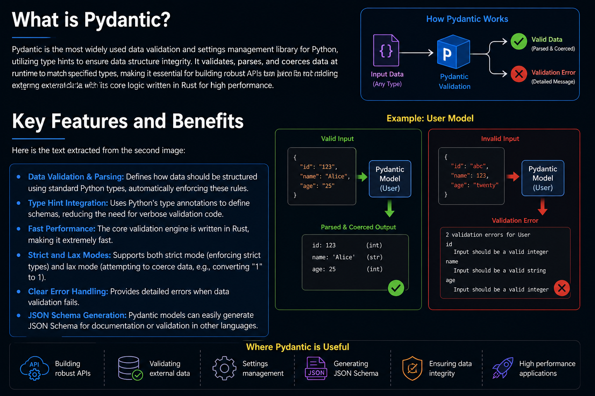

How to Use Pydantic
1. Define a Pydantic model that represents the ideal schema of the data.
. This includes the expected fields, their types, and any validation constraints (e.g., gt=0 for positive numbers).

2. Instantiate the model with raw input data (usually a dictionary or JSON-like structure).
. Pydantic will automatically validate the data and coerce it into the correct Python types (if possible).
. If the data doesn't meet the model's requirements, Pydantic raises a ValidationError.

3. Pass the validated model object to functions or use it throughout your codebase.
. This ensures that every part of your program works with clean, type-safe, and logically valid data.

